Copyright for test papers and marking guides remains with West Australian Test Papers.
Test papers may only be reproduced within the purchasing school according to the advertised Conditions of Sale.
Test papers should be withdrawn after use and stored securely in the school until Friday, 30th June 2017.



SEMESTER ONE

MATHEMATICS
METHODS
UNITS 1

2017

SOLUTIONS

Calculator−free Solutions

1. (a) (i) 
(ii)  or 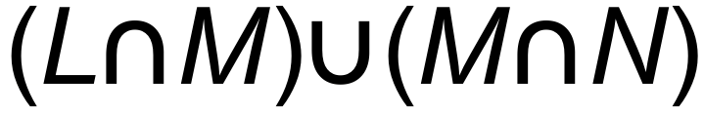
(b) (i)  = {3}
(ii) 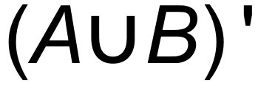 = {8, 9, 10, 14, 15, 16, 18, 19}
(iii) 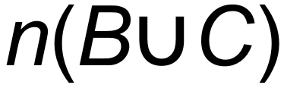 = 8 [5]

2. (a) (i) 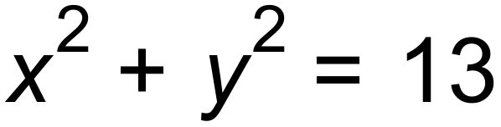
(ii) 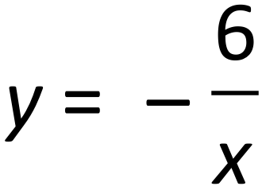
(iii) 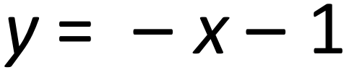
(b) 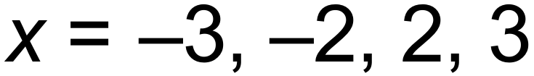
(c) (i) (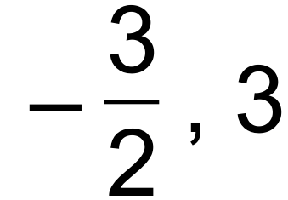)
(ii) m = 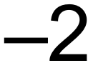 [11]

3. 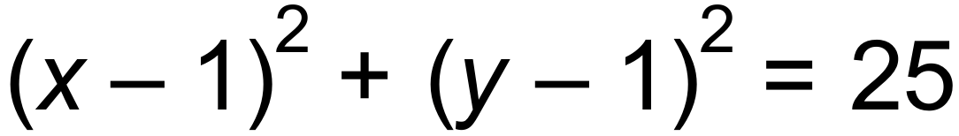
Centre (1, 1)
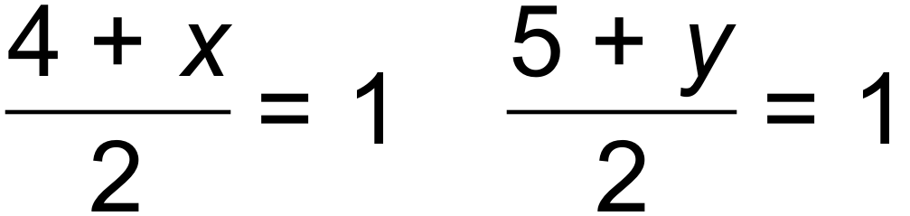
M 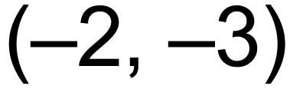 [4]

4. (a) 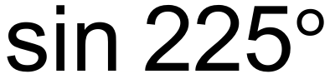
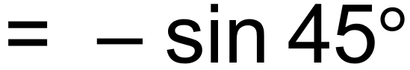
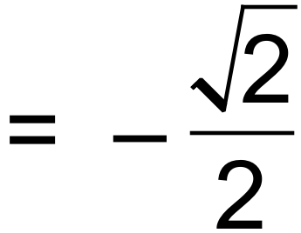
(b) 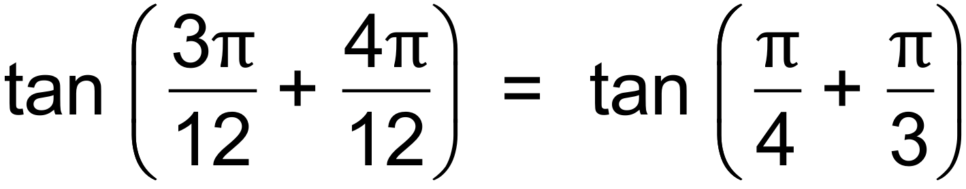
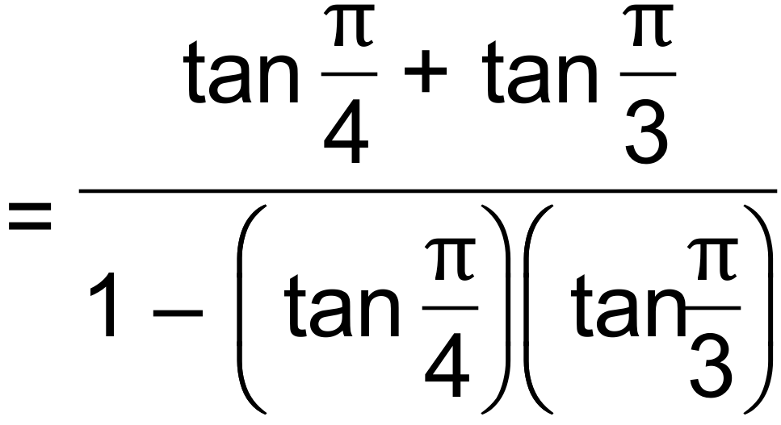
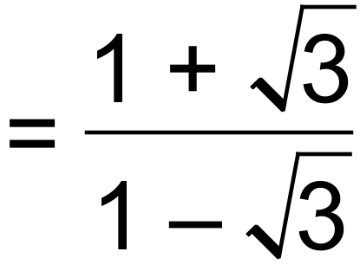
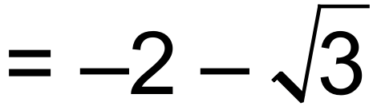 [6]

5. (a) 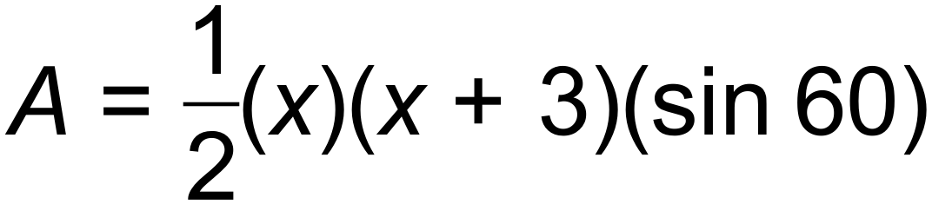
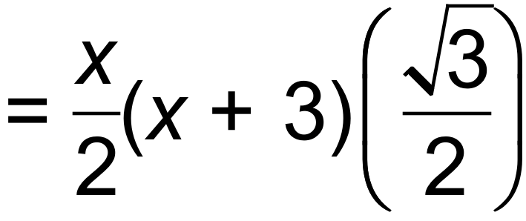
= 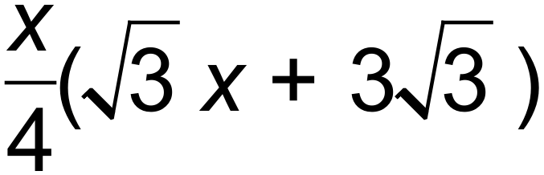 cm²
(b)
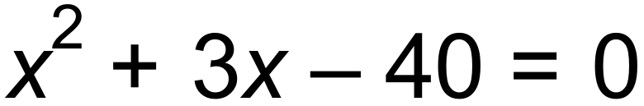
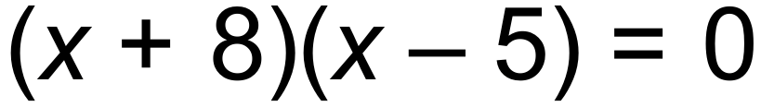
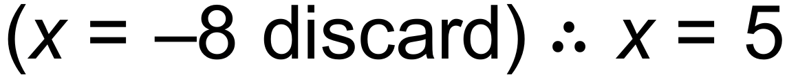
(c) 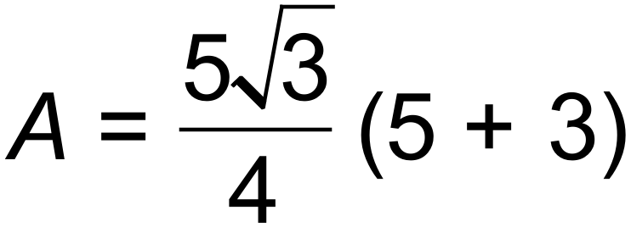
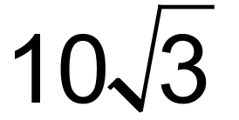 cm² [7]

6. (a) 60%
(b) 40%
(c) 70%
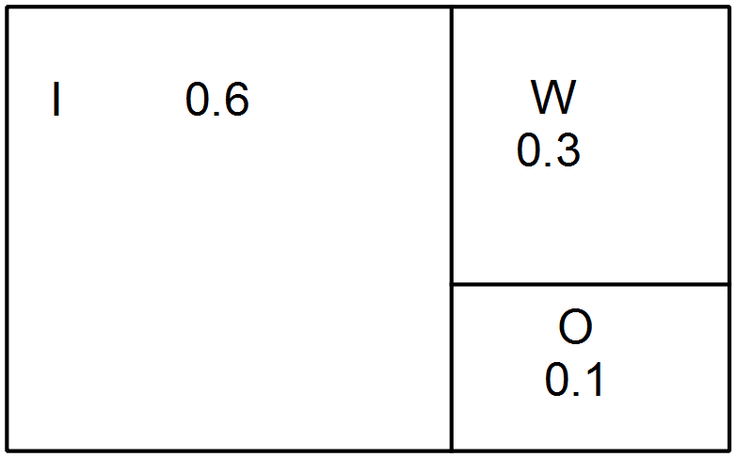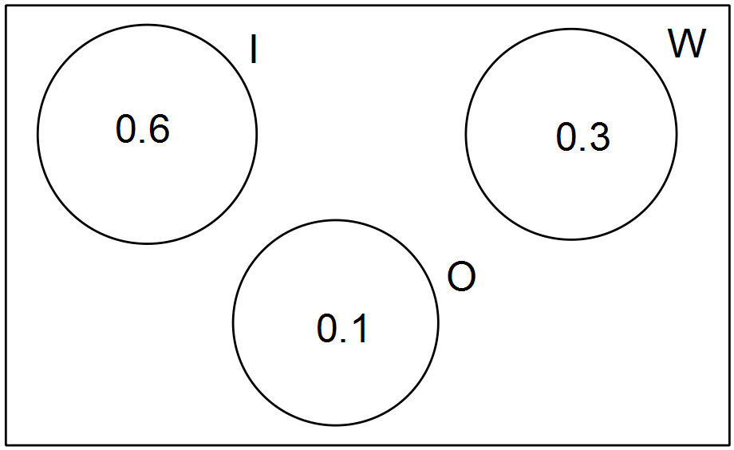(d)
Or

[5]

7. (a) 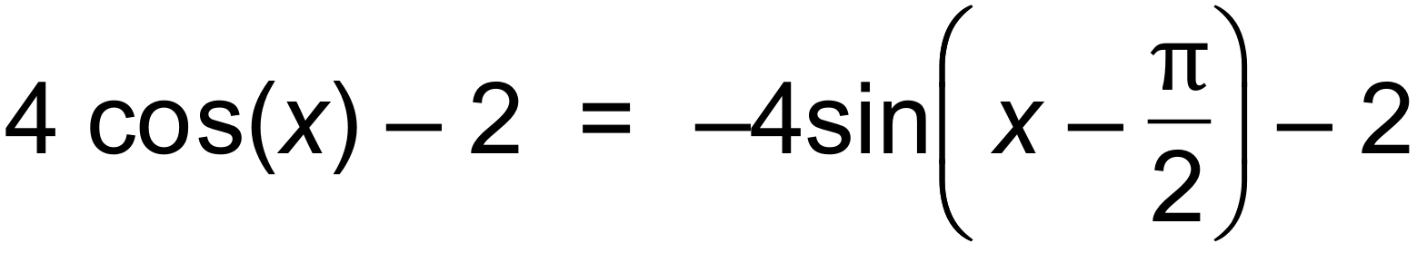
(b) R_{k(x)}= 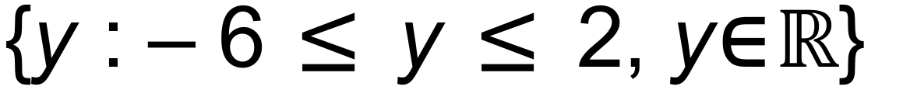
(c) For every x value there is only one y value
Vertical line through graph [8]

8. (a) 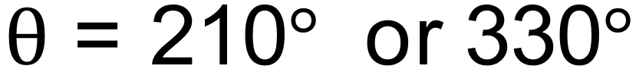
(b) 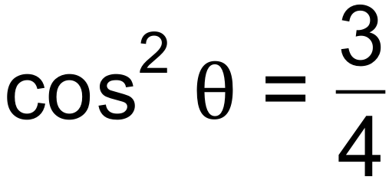
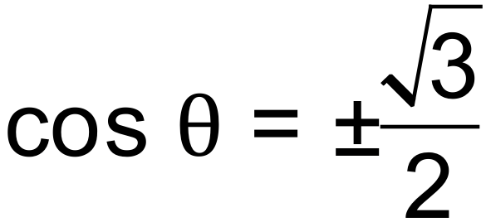
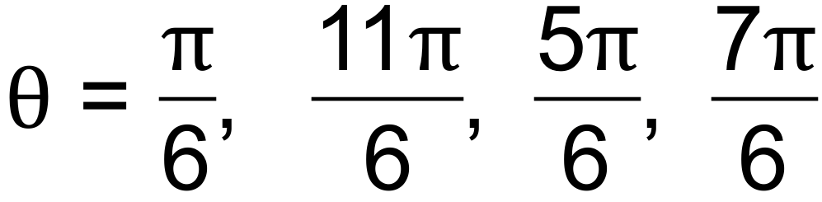 [5]

Calculator−assumed Solutions

9. (a) (i) 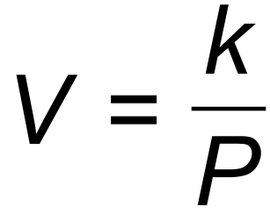
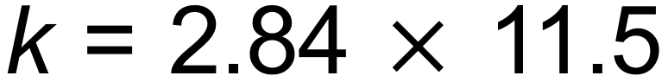
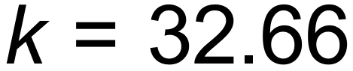
(ii) The volume doubles.
(b) 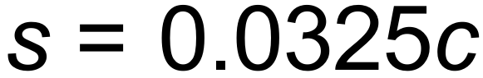 is a linear relationship in the form 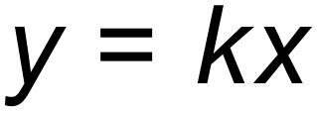 where
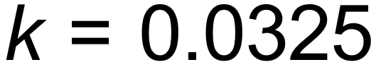 and is therefore directly proportional. [5]

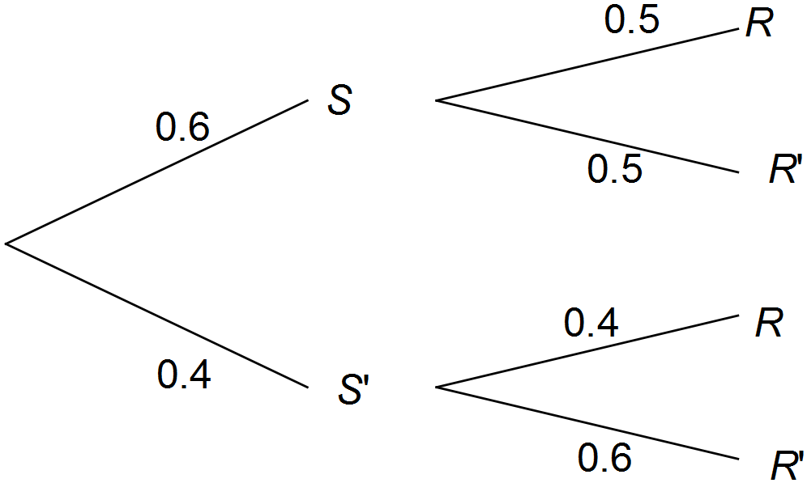10. (a)

(b) (i) 0.3
(ii) 0.24
(iii) 0.46
(iv) 0.348 or 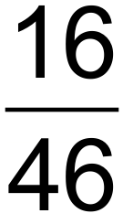 [9]

11. (a) 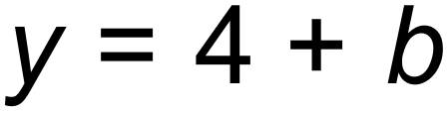
(b) 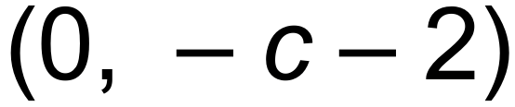
(c) 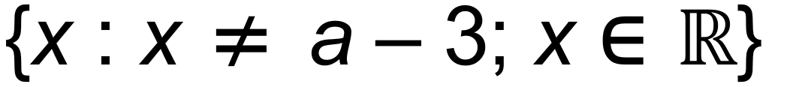 [5]

12. (a) 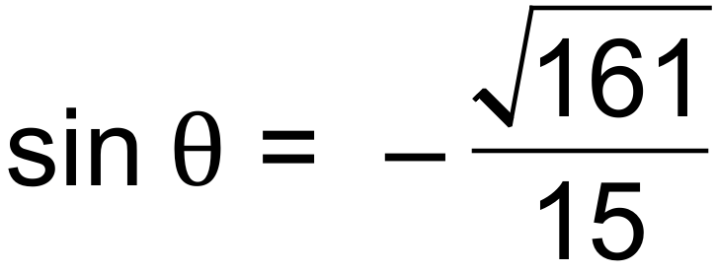
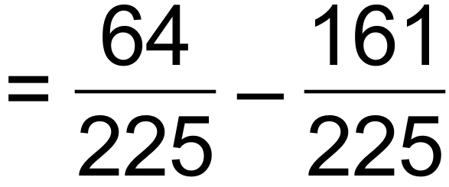
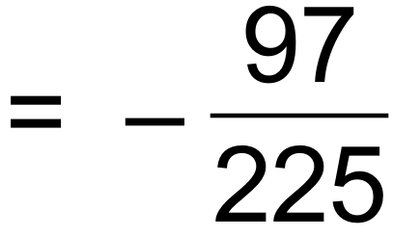

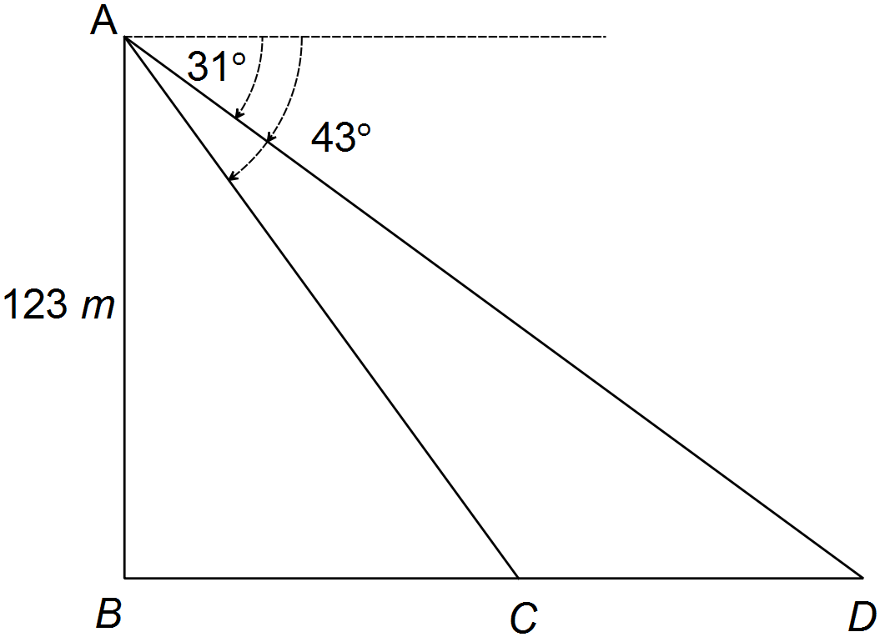(b) 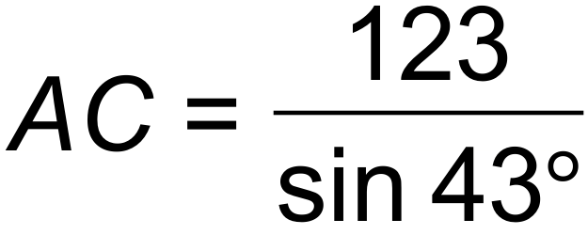
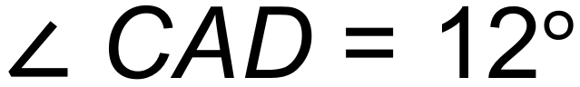 and 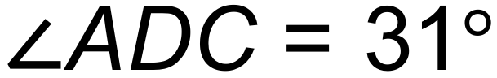
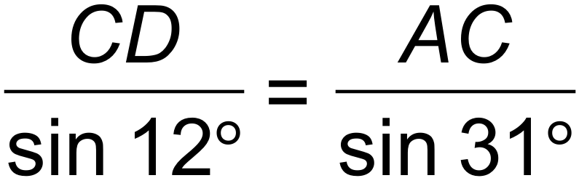
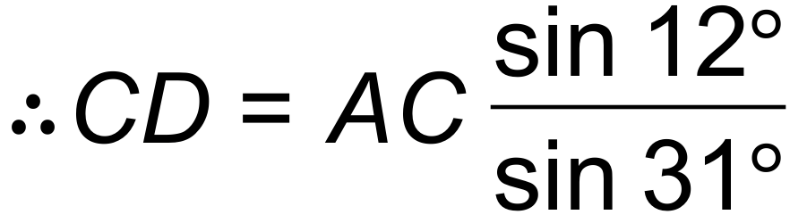
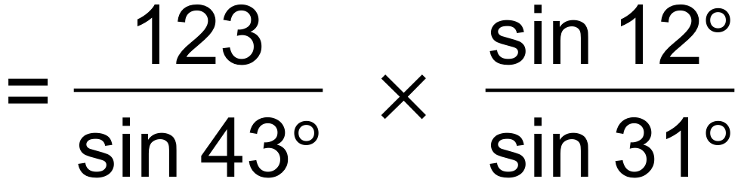
= 73 m [8]

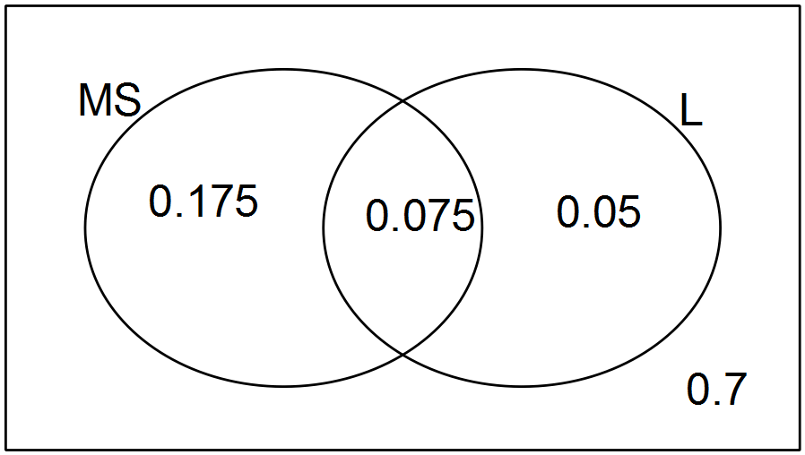13. (a)

(b) 0.075
(c) 133
(d) 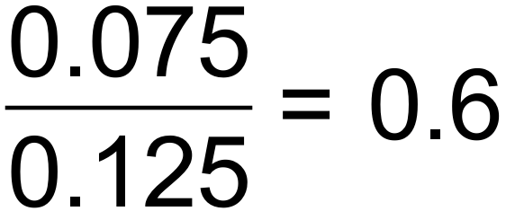
(e) to be independent.
Therefore not independent or [9]

14. (a) (i) 3
(ii) 0
(iii) 1
(b) Domain of 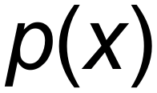 is the same as 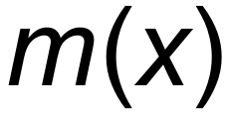. For both: 
(c) 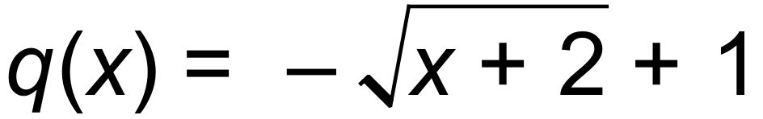
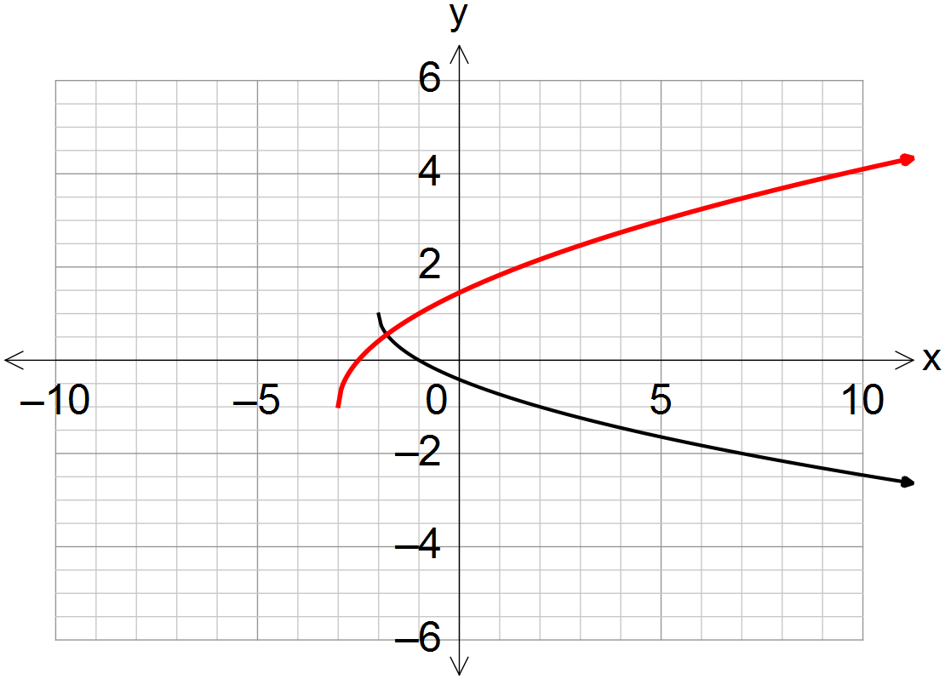 (d)

[10]

15. (a) 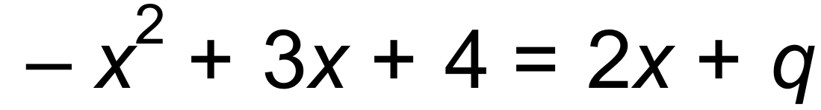
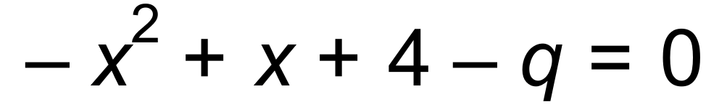
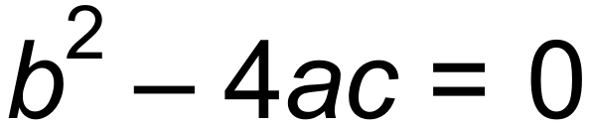 for one solution
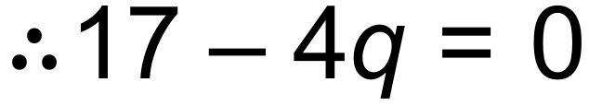
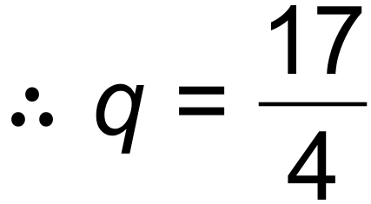
(b) 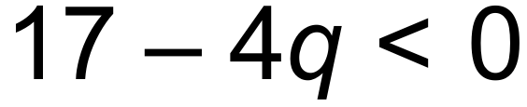
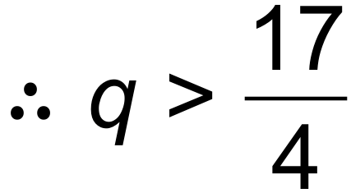 [6]

16. (a)
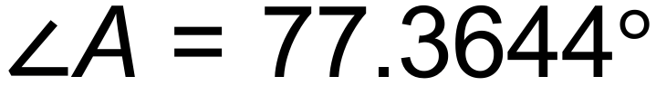 or 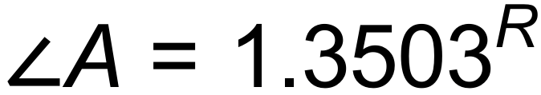
Area 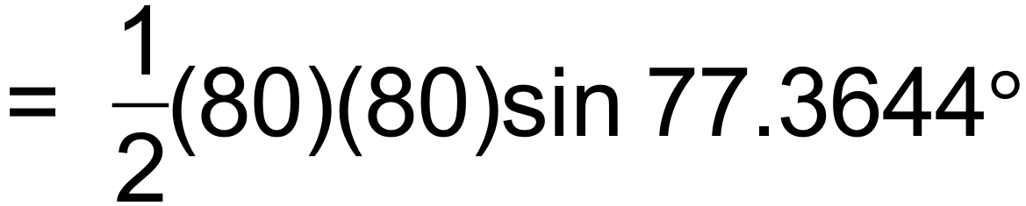
= 3122.4993 cm²
(b)
Area of sector = 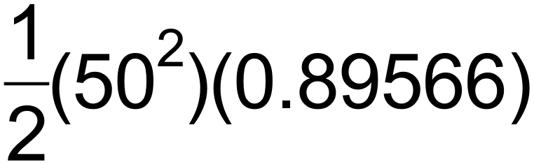
= 1119.56 cm²
Area of small sector = 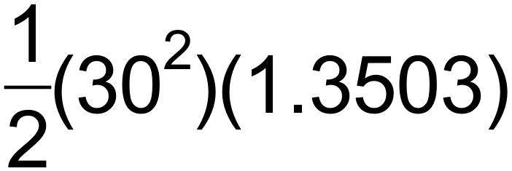
= 607.635 cm²
Area of shaded section = 3122.4993 – (2)(1119.58) – (607.635)
= 275.704
= 276 cm² [7]

17. (a) (i)
(ii) 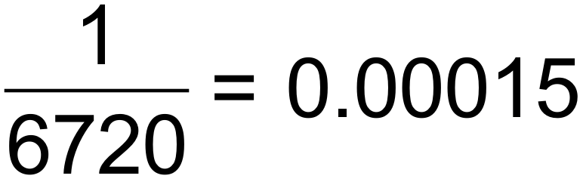
(b) (i)
(ii) 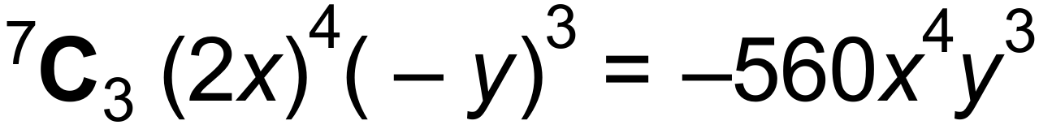
(c) (i) 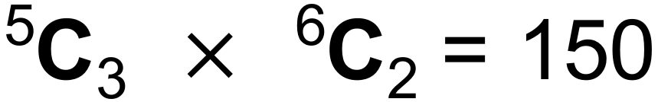
(ii) [10]

18. (a) 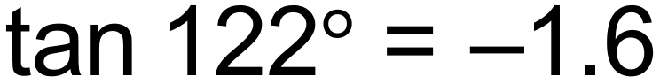
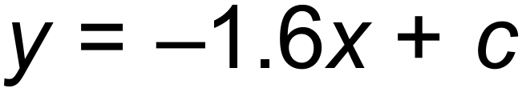
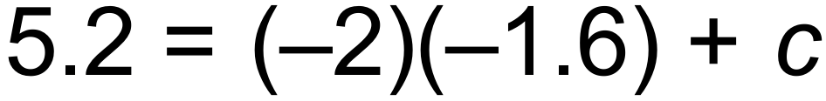
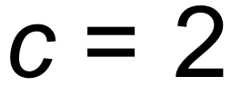
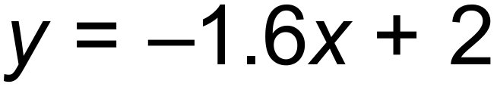
(b) 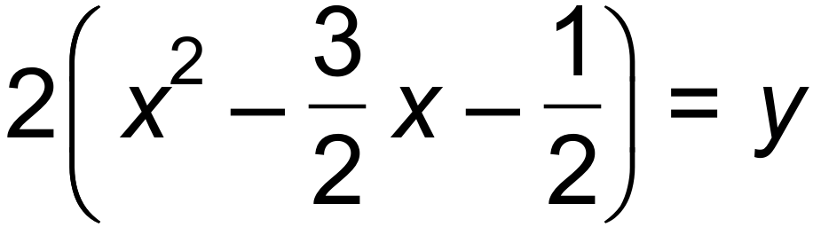
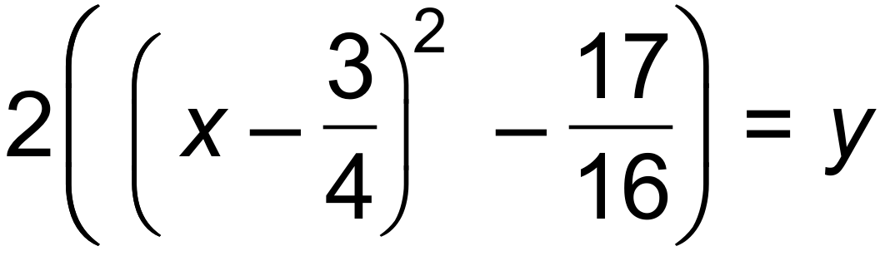
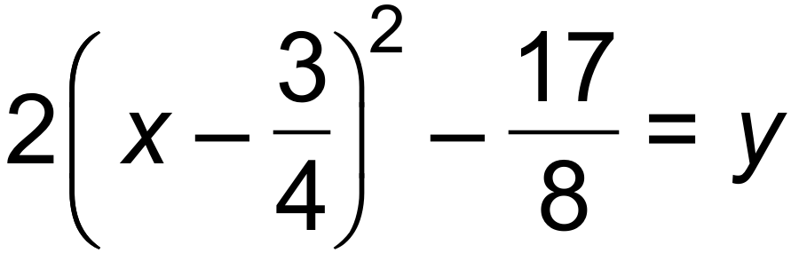
Turning Point ( 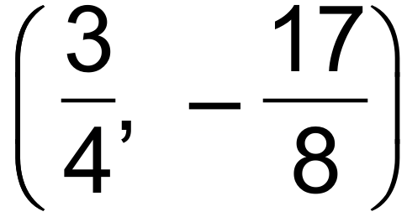
(c) (i) 1 m
(ii) 5.5m
(iii) 1.77 m or 28.23 m away [9]

19. (a) 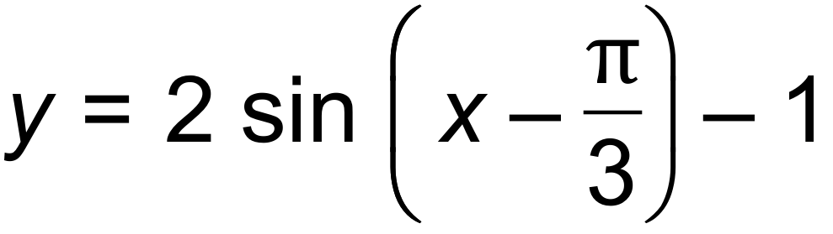
(b)
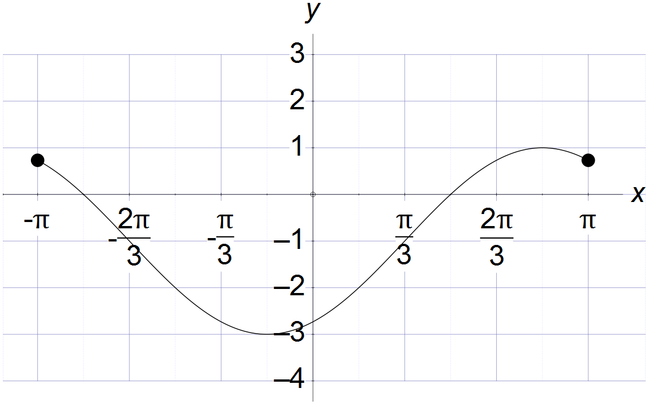
(c) 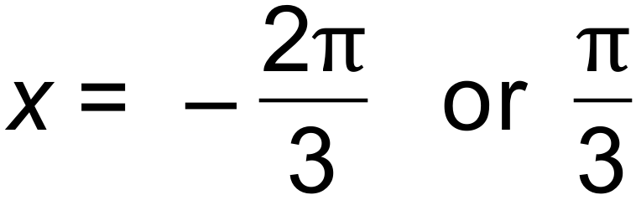 [6]

20. (a)
 | H | 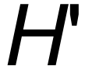
 | 0.4 | 0.3 | 0.7
 | 0.2 | 0.1 | 0.3
 | 0.6 | 0.4 | 1

(b) (i) 0.3
(ii) 0.6
(iii) 0.1
(iv) 0.9
(v) 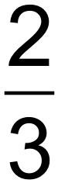
(c) Not mutually exclusive: P() = 0.4 Should be 0 [10]

21. (a) C 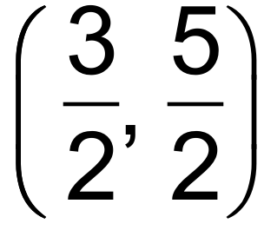 r = 3
(b) (i) 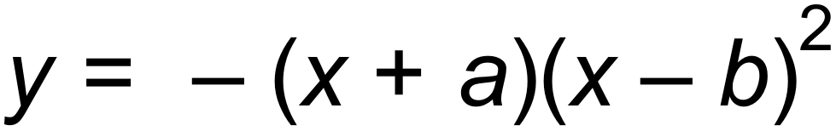
(ii) 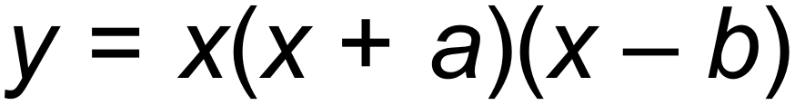
(iii) 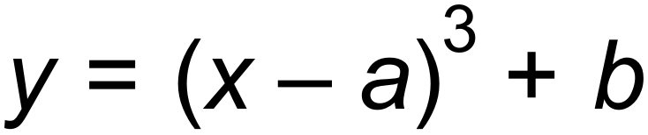 [5]

End of Questions

